Noah Hughes

Facebook

<https://www.facebook.com/>

The main purpose of this app is to allow people to share images and things about their life with family and friends.

Test 1: follow the link to be brought to the log-in or sign-up page.

Test 2: sign-in to your account or create one then it will bring you to the main screen or (feed) and show you updates.

Test 3: Click on your name and picture in the top left and it will take you to your account.

Test 4: Click edit profile and a pop-up will appear to make changes to your photos, information, and other personal details.

Test 5: Next click on friends right below your profile picture and a list of all the people you are friends with will come up.

Test 6: In the same friend’s screen in the right corner click find friends and you can click add a friend to become friends with people you know.

Grocery Shopper

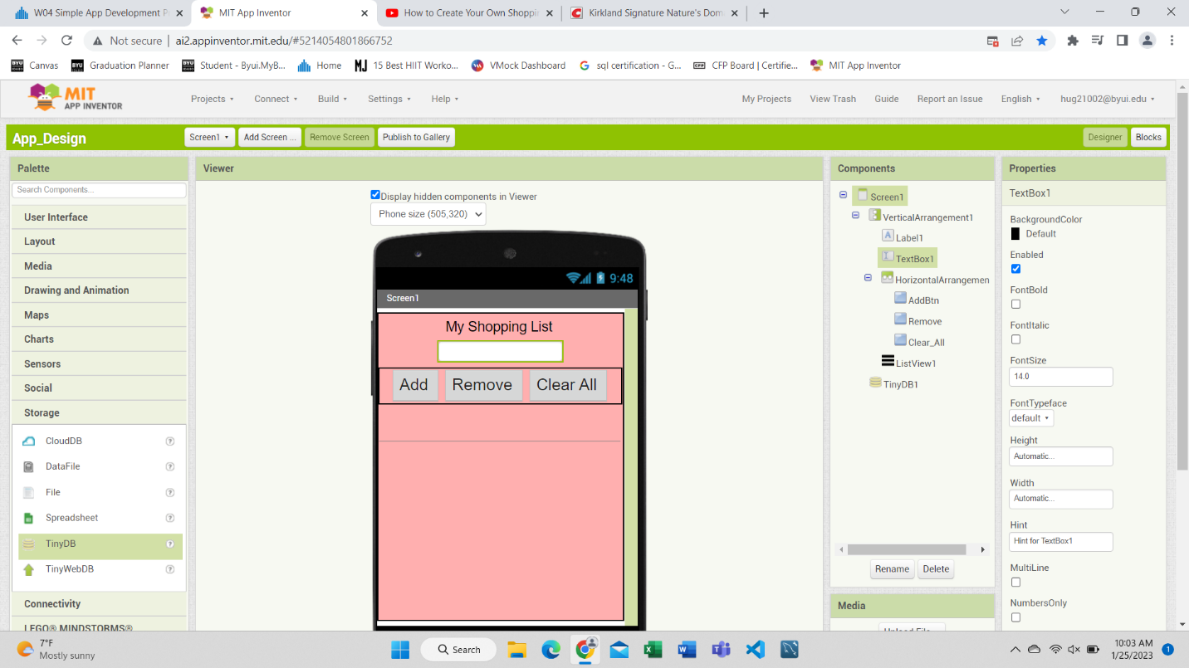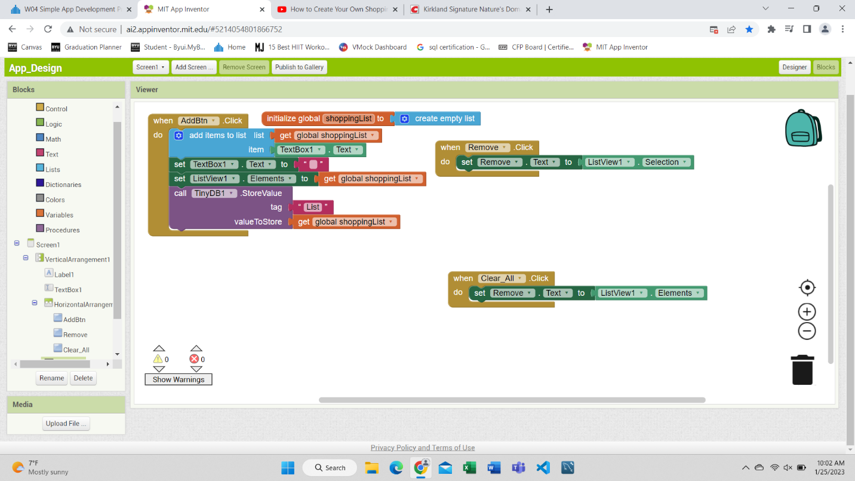

The question that I decided to make an app for was an issue I often run into. Everyone needs food and other things to survive for most of us that means we must go to the store to get the things we need to purchase. Yet we often get distracted and do not get everything we need or get more things than we intended. I will normally try to write a list of products to purchase, and I always seem to either lose the list or forget it in the car or at my apartment. One solution to this problem is typing the list on my phone but I do not just have boxes to check to mark what I have already gotten. Hopefully, I am not the only forgetful one with this problem. This app can be used for many things other than shopping, any list you need can be made here, that’s just what I tend to need lists for the most and struggle to keep track of.

The solution I have come up with is to create an app that allows you to create a list and automatically applies checkboxes to it so you can see all the things you need and tell the app to remove them once it is purchased. So, when you input things, you need all you must do is click the box acknowledging you have gotten the product while at the store since most people never go anywhere without their phone it would be hard to forget that like I often do with my lists.

Looking forward the solution I hope to provide after the end of this project is an app that people manually type in different products, they need the app. After this, the app shows them their list with the different products in it. Once they have gotten the product or realize they no longer want or need it, they must click the check box which tells the app that the product can be removed from the list.